Basic structure of the classes which carry out JMS:

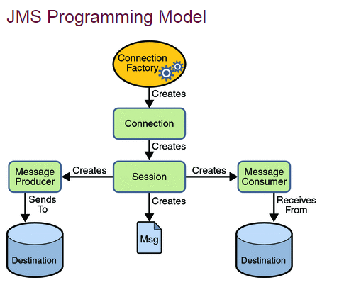

The way in which message provider and consumer communicate:
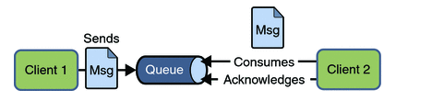

The way in which message publisher and subscriber communicate:
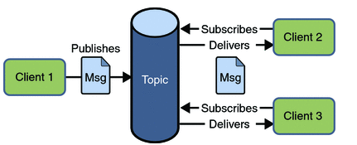

The .jar files that should be added:
javax.jms.jar
.jar files of activeMQ

How to carry out synchronization JMS communication:
receive method

How to carry out asynchronization JMS communication:
onMessage method

